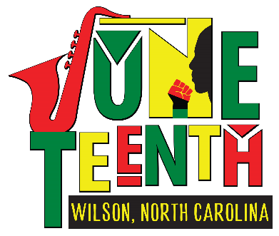
2026 Wilson Juneteenth Festival
June 13, 2026 – Toisnot Park – 11 am – 8 pm

Sponsor Commitment

Organization/Business Name: ____________________________________________________________________
Check One: New Sponsor Returning Sponsor – last year participated: _________

Contact Name: _________________________________________________________________________________

Mailing Address: ________________________________________________________________________________
Street/PO Box City State Zip

Day Phone: (______)____________________________Alternate Phone: (_____)___________________________

Email: ________________________________________________________________________________________
(For speed and convenience, most communication will be done via email and website postings please check both regularly.)

Fax Number: __________________________________________________________________________________

Website: ______________________________________________________________________________________

Sponsor Involvement Level: $ ____________________ check #________ date rec’vd:___________

 | Sponsor Levels | Donation Amount | Your Sponsor Benefits Include:
 | - Presenting Sponsor | $5,000 + | Benefits that apply to your level has been marked below:  - Inclusion in all marketing  - Inclusion in printed materials  - Inclusion in social media promotions  - Logo on Sponsor signage within festival zone  - Logo on festival t-shirt  - Business name listed on t-shirt  - “Proud Sponsor” yard sign  - Complimentary booth at festival: single / double / triple  - Other:
 | 2. Gold Sponsor | $1,000 +
 | 5. Red Sponsor | $500 +
 | 6. Green Sponsor | $100+  In kind gifts  In kind services

- April 30 – All sponsorship payments and commitment forms must be received to be included in printed promotional materials prior to the festival, such as posters.
- May 18 - All sponsorship payments and commitment forms must be received to be included in printed festival day materials, such as schedules, banners and signage.
- June 1 - Sponsors requesting booth space at the festival must submit their completed booth form.

Sponsor Interactions:
The goal of the festival is to connect Sponsors to potential clientele by providing opportunities for interactions. Provided below is an outline of how you will be included in festival activities: _______________________________________________________________________________________________

Festival Sponsor Booth: (Note – sponsors may not donate their space to others.)

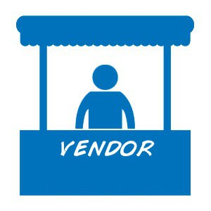
Check one:
No thank you, we do not want a booth at the festival.
Yes, we want to have a booth at the festival.
Booth Utilities: Limited water and electricity are available for vendors and will be considered on as-needed-basis.

Request electricity access (one 110 v outlet). Request electrical 240 access
Request water access

Will you bring a tent to use? No Yes (10 x 10 ft allowed)

Describe your Sponsor Booth:
The festival strives to insure activities, handouts, giveaways, etc.. do not conflict with paying vendors and the Wilson Juneteenth Festival merchandising. To assist all vendors in being successful, please provide a description of your booth’s activity, service or demonstration planned:
_______________________________________________________________________________________________________

Attach Photo of booth Display – New Sponsors please enclose a photograph of your booth set up.

Booth Items - New Sponsors please enclose a photograph of the items for sale or giveaways in the booth.

Insurance – Each booth must provide their own insurance to cover sales, products, and operations.
Company:____________________________________ Policy #:______________________ Expiration date: ______________

NC Sales Tax ID Number: - ____________________________________________________________________________

Festival Policies:
I have reviewed the Wilson Juneteenth Festival booth policies and procedures and agree to abide by the policies as outlined, including that the festival is held rain or shine and that booth fees are non-refundable.

I understand as a vendor of the festival that I am a representative of the festival and will act as an example to the community. I understand that I am vending at my own risk and I agree to be responsible for my own safety, protection of belongings and actions. I further agree to indemnify and hold harmless the Wilson Juneteenth Festival organizers, City of Wilson, and any persons holding legal title to the lands upon which this event is being held, from any claims arising from my participation as a vendor in this festival.

Signature: _______________________________________________________________Date: _________________
Please make your tax-deductible sponsorship payable to Wilson Juneteenth Festival. The Wilson Juneteenth tax id number is 23-0854993. We look forward to working with you to customize your sponsorship to incorporate community outreach and help increase your engagement with potential clients.
Please contact Michael McHarg, our sponsorship coordinator, by calling (252) 363-1600 or emailing him at Michael@bigfishdigitalsigns.com to discuss ways to support our community.
Your support is integral in helping establish Wilson’s Juneteenth Festival, a major celebration in our community and region. Thank you very much!

